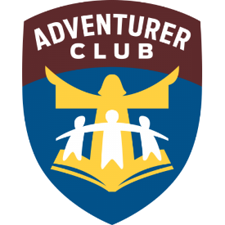
Chesapeake Conference Adventurer Awards Day
October 16, 2022
Ellicott City Seventh day Adventist Church
3291 Saint John’s Lane - Ellicott City, MD 21042
Speaker: Pastor Debbie Rivera

WELCOME | Little Lambs  (4 yrs. old)  Kindergarten Room | Eager Beaver  (5 yrs. old)  Chapel Room | 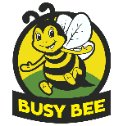  Busy Bee  (1st grade)  Primary Room | Sunbeam  (2nd grade)  Classroom 1 | Builder  (3rd grade)  Outdoors & Gym | 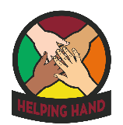  Helping Hand  (4th grade)  Outdoors
Check –in begins at 9:00 am – Opening Prayer – 10:00 am
Session I  10:30 – 11:15 am | FL - Jump  Samantha & Sabine Dorestal  (Coordinator) | FL - Trucks  Ian Grant  (Triadelphia) | FL – Things That Go  Karen Graham  (Waldorf) | FL - Turtles  Sharon & Sheridan Marinkovic  (Coordinator) | FL Carpentry Fun  Felix Nieto  (Pathfinder Coordinator)  Front Lawn under Canopy | NAD  Soap Making  Stacie & Billy Errico  (Coordinator)  Front Lawn under Canopy
Session II  11:30 am – 12:15 pm | FL – Puppets | FL – Dirty Coins  Samantha & Sabine Dorestal  (Coordinator) | CC- Apples  Tim Lee  (Coordinator) | FL - Wild West  Sandy Thomas  &  Ann Reynolds  (Coordinator & Conference)
Lunch Break – 12:15 – 1:30 pm
Session III  1:45 pm – 2:30 pm | FL - Travel  Ian Grant  (Triadelphia) | FL - Recycling  Genevia Brown  (Coordinator) | FL - Finger-painting | FL – Chenille & Pompons | FL - 5 Senses  Tina & Zach Gagliardi  (Highland View)  GYM | FL - Dress-Right-Dress  Sabine Dorestal  (Coordinator)  Parking near Church
Have a Safe Trip Home

FL = Florida Award CC = Chesapeake Award NAD = North American Division Honor

